This section covers launching a virtual server in the cloud and setting up the Jenkins automation server.
Step 1.1: Launch EC2 Instance
- Log in to your AWS Management Console.
- Navigate to EC2 > Launch Instance.
- Name: Jenkins-Server.
- AMI: Select Ubuntu 24.04 LTS.
- Instance Type: t2.micro (Free Tier eligible).
- Key Pair: Create a new one (e.g., my-key.pem) and download it.
- Network Settings: * Allow SSH (Port 22).
  - Allow Custom TCP (Port 8080) from "Anywhere" (0.0.0.0/0).
- Click Launch Instance.
Step 1.2: Connect and Install Jenkins
Open your terminal (or PowerShell) and SSH into your instance:
Bash
ssh -i "my-key.pem" ubuntu@your-ec2-public-ip
Once connected, run these commands to install Java and Jenkins:
Bash
# Update system
sudo apt update && sudo apt upgrade -y

# Install OpenJDK 17 (Required for Jenkins)
sudo apt install openjdk-17-jdk -y

# Add Jenkins Repo and Key
sudo wget -O /usr/share/keyrings/jenkins-keyring.asc https://pkg.jenkins.io/debian-stable/jenkins.io-2023.key
echo "deb [signed-by=/usr/share/keyrings/jenkins-keyring.asc] https://pkg.jenkins.io/debian-stable binary/" | sudo tee /etc/apt/sources.list.d/jenkins.list > /dev/null

# Install Jenkins
sudo apt update
sudo apt install jenkins -y

# Start Jenkins
sudo systemctl enable jenkins
sudo systemctl start jenkins
Step 1.3: Access Jenkins UI
- Go to http://<your-ec2-public-ip>:8080.
- Retrieve the initial password from your terminal: sudo cat /var/lib/jenkins/secrets/initialAdminPassword
- Follow the wizard to install suggested plugins.

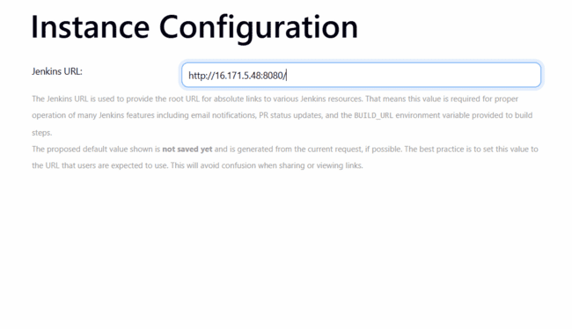
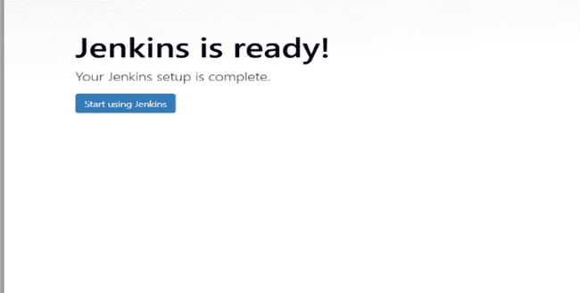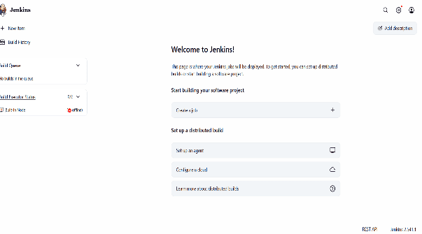

Setup Apache Tomcat on Ubuntu VM

2. Setup Apache Tomcat on Ubuntu VM
Tomcat is often used to host Java .war files.
Step 2.1: Install Java and Create User
Bash
sudo apt update
sudo apt install openjdk-17-jdk -y
sudo useradd -m -U -d /opt/tomcat -s /bin/false tomcat
Step 2.2: Download and Extract Tomcat 10
Bash
cd /tmp
wget https://dlcdn.apache.org/tomcat/tomcat-10/v10.1.26/bin/apache-tomcat-10.1.26.tar.gz
sudo tar -xf apache-tomcat-10.1.26.tar.gz -C /opt/tomcat --strip-components=1
sudo chown -R tomcat: /opt/tomcat
sudo chmod -R +x /opt/tomcat/bin

Step 2.3: Configure as a Service
Create a file: sudo nano /etc/systemd/system/tomcat.service and paste:
Ini, TOML
[Unit]
Description=Apache Tomcat 10
After=network.target

[Service]
Type=forking
User=tomcat

Group=tomcat
Environment="JAVA_HOME=/usr/lib/jvm/java-17-openjdk-amd64"
Environment="CATALINA_HOME=/opt/tomcat"
ExecStart=/opt/tomcat/bin/startup.sh
ExecStop=/opt/tomcat/bin/shutdown.sh

[Install]
WantedBy=multi-user.target
Start service: sudo systemctl daemon-reload && sudo systemctl enable --now tomcat. Access: http://<vm-ip>:8080.

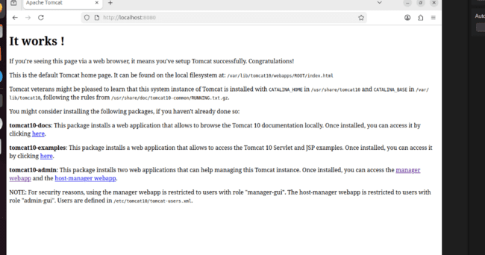

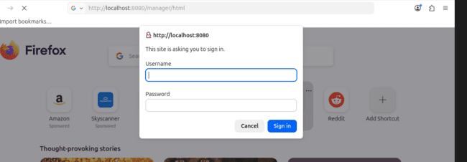
Setup Docker Desktop on Local Windows

3. Setup Docker Desktop on Local Windows
Docker allows you to package and run applications in containers.
Step 3.1: Enable WSL 2 (Prerequisite)
- Open PowerShell as Administrator and run: wsl --install
- Restart your computer if prompted.
Step 3.2: Install Docker Desktop
- Download: Go to Docker's official site and click Download for Windows.
- Run Installer: Double-click Docker Desktop Installer.exe.
- Configuration: Ensure "Use WSL 2 instead of Hyper-V" is checked.
- Finish: Click Ok, wait for installation, and click Close and Restart.
- Accept Terms: Upon restart, open Docker Desktop and accept the service agreement.
Step 3.3: Verify Installation
Open a command prompt (CMD) and type:
Bash
docker --version
docker run hello-world

